How to install your 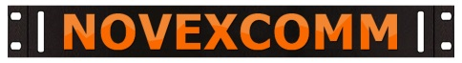 Mounting Brackets
INSTALLING THREADED INSERTS (RIVET NUTS) IN THE YASEU GSX-232 CASE
YOU NEED A RIV-NUT TOOL WITH 6/32 THREADED INSERTS AND TIP
BE CAUTIOUS; THAT 6/32 TIP IS EASILY BROKEN, BE GENTLE WHEN USING IT
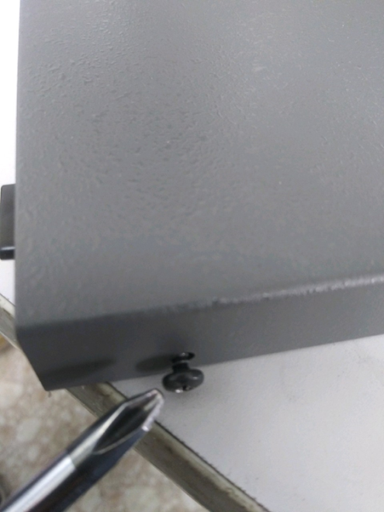 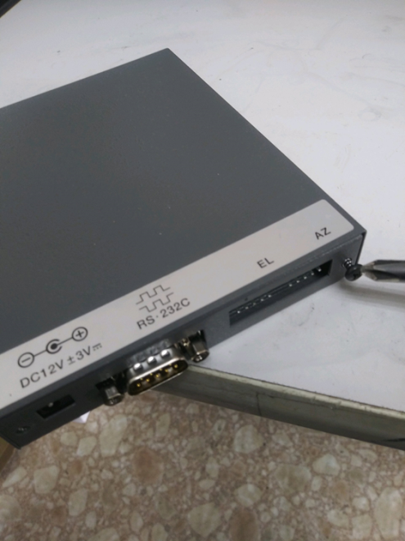 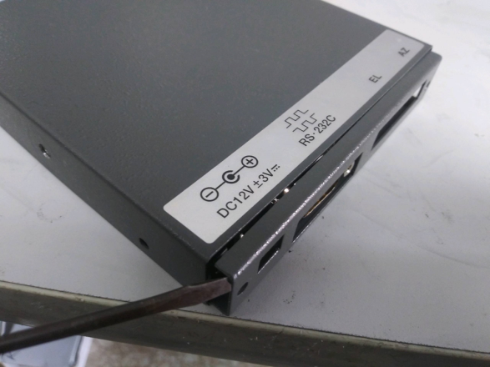 REMOVE ALL CASE SCREWS AND THEN PRY OFF THE REAR PANEL GENTLY
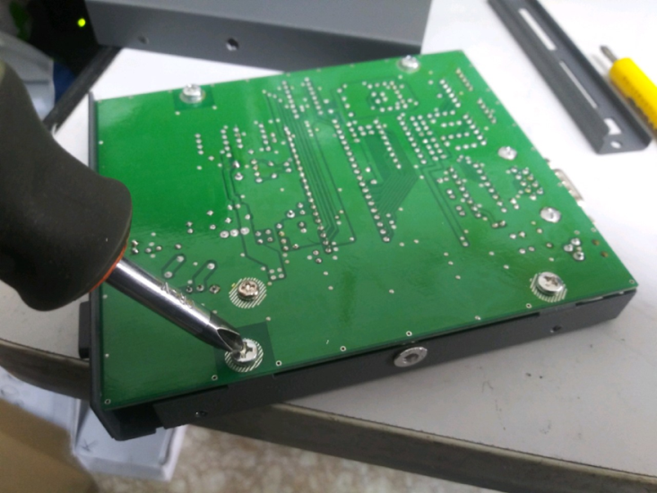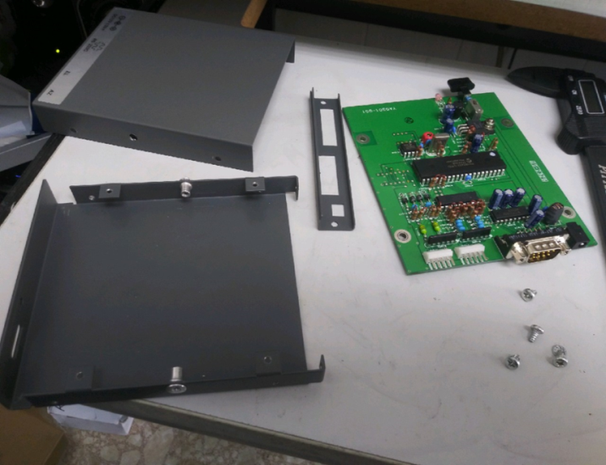
INNER CASE
OUTER CASE
REMOVE THE PC BOARD AND SET IT ASIDE: INSERTS GO INTO THE INNER CASE ONLY
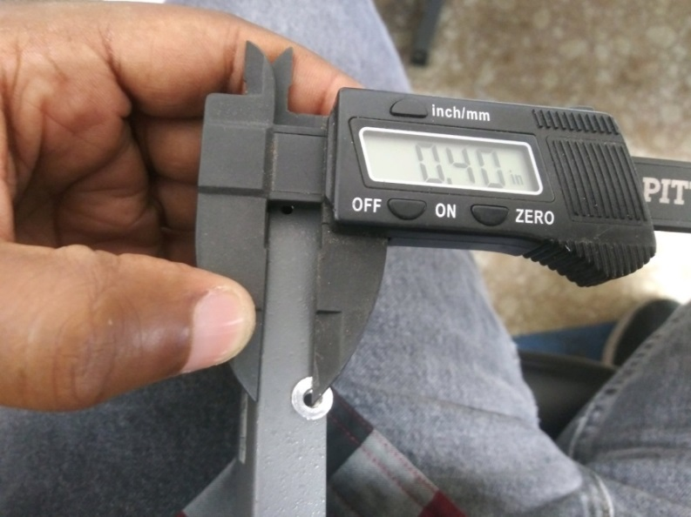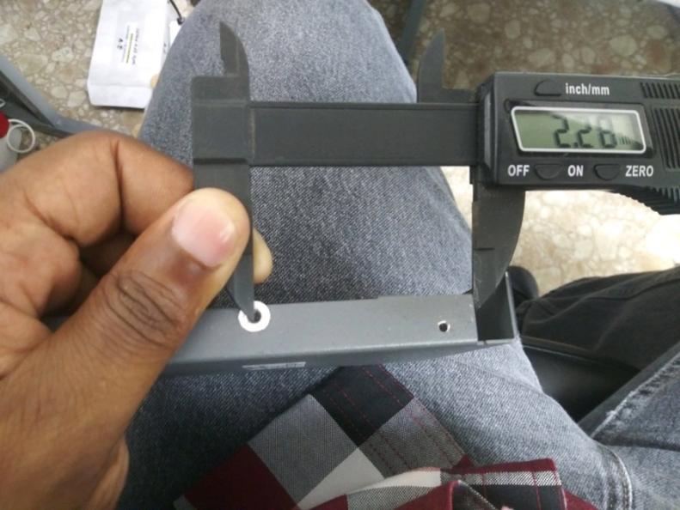
NOTE THE OFFSET LOCATION
MARK & DRILL INNER CASE FOR INSERTS NOTE THE LOCATION FOR THE INSERTS
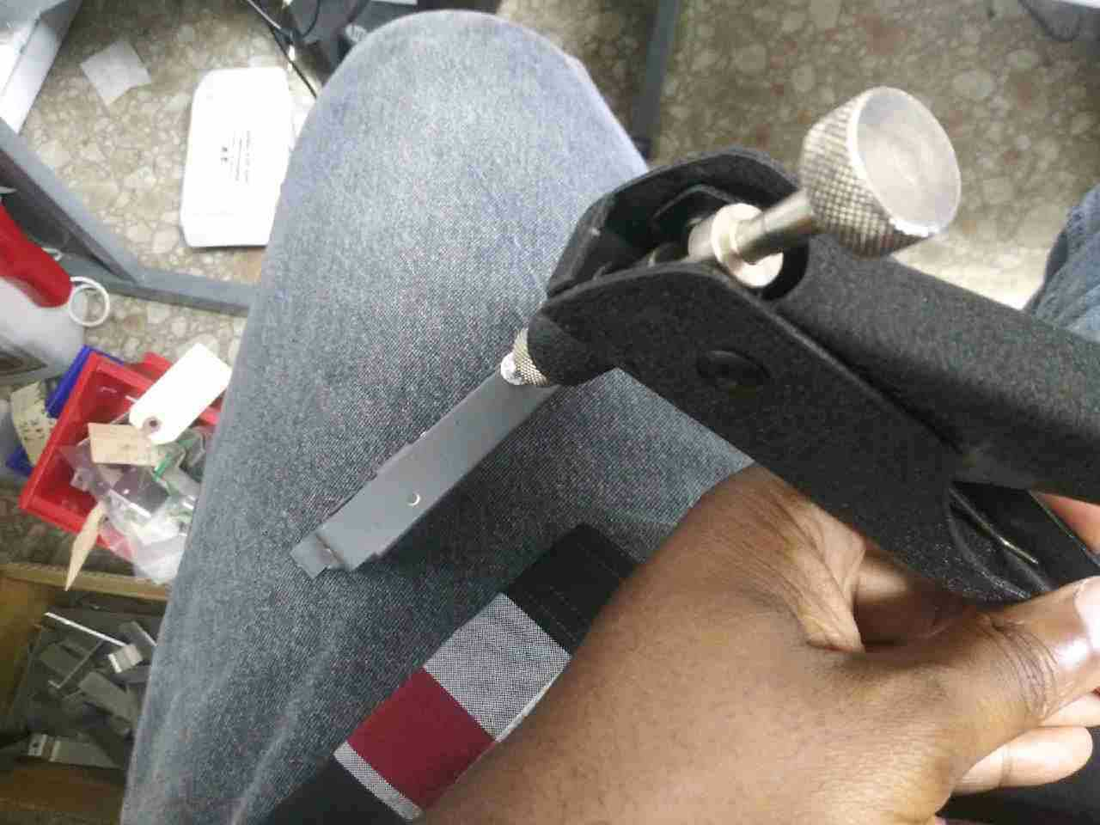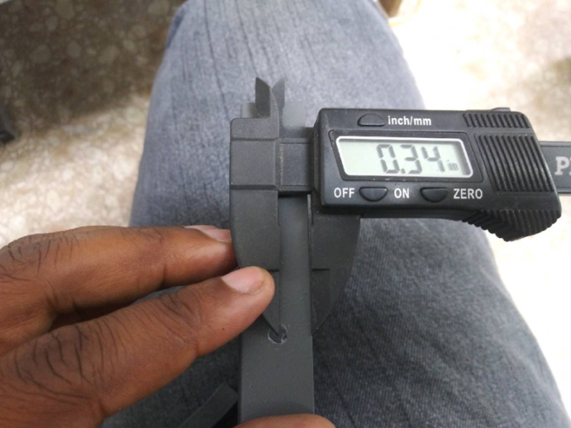
INSTALL INSERTS GENTLY, TIP BREAKS EASILY MEASURE AND DRILL OUTER CASE LARGER
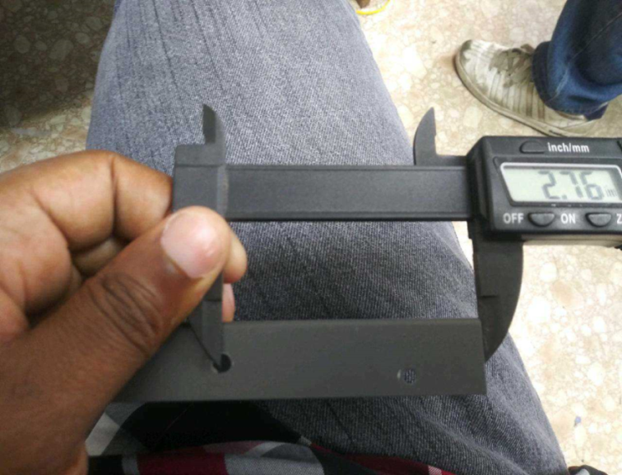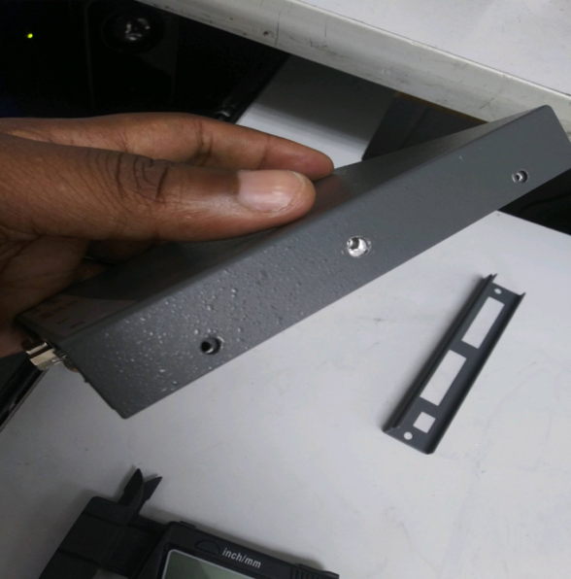
SEE THREADS INSIDE
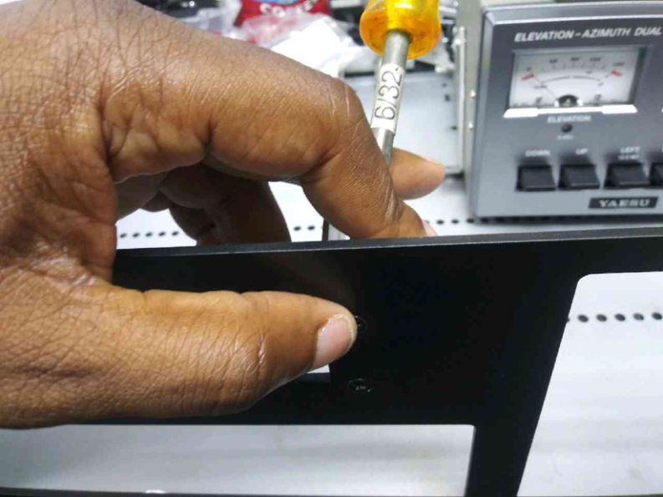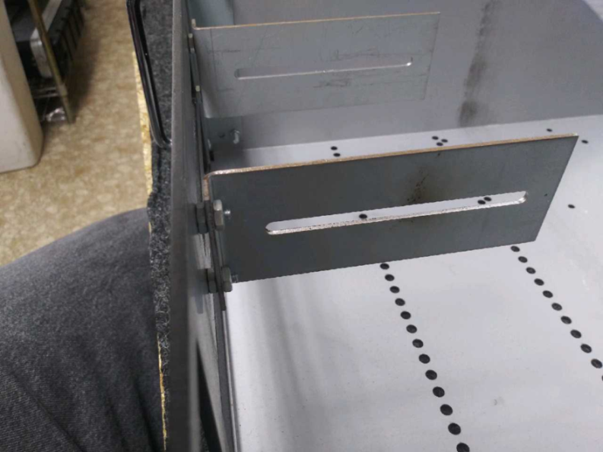
INSTALLATION OF THE “WINGS” BRACKETS FOR GSX232 TO FRONT PANEL PRE-ASSEMBLED
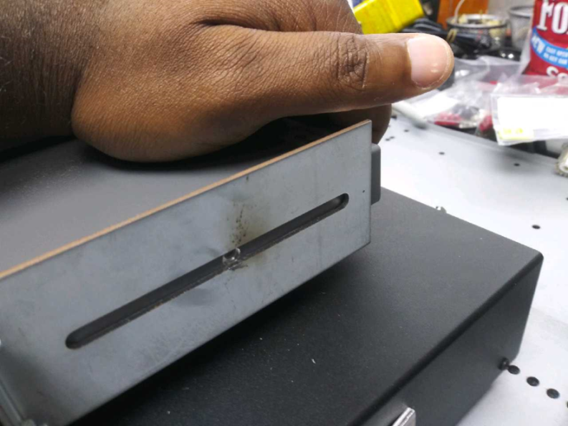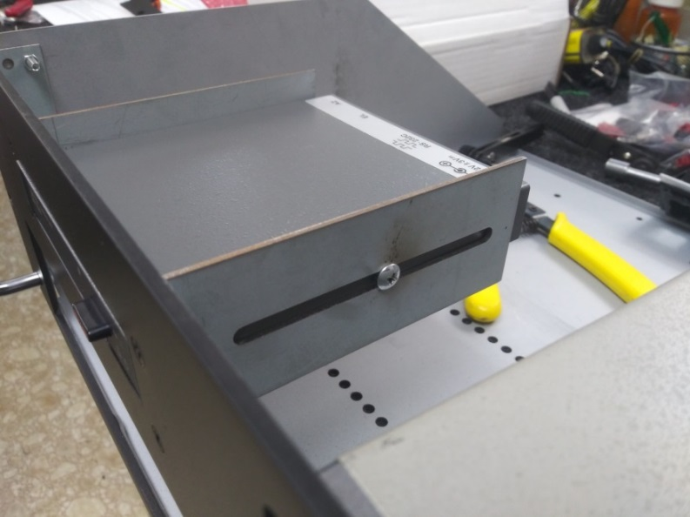
SNUG FIT, JUST BARELY MAKES IT

